The Surelite I-20 can generate laser light at the Nd:YAG fundamental wavelength (1,064 nm) or its second harmonic (532nm). 20hz repetition rate, producing 7.5 watts average (375 mJ/pulse), @6ns pulse width.

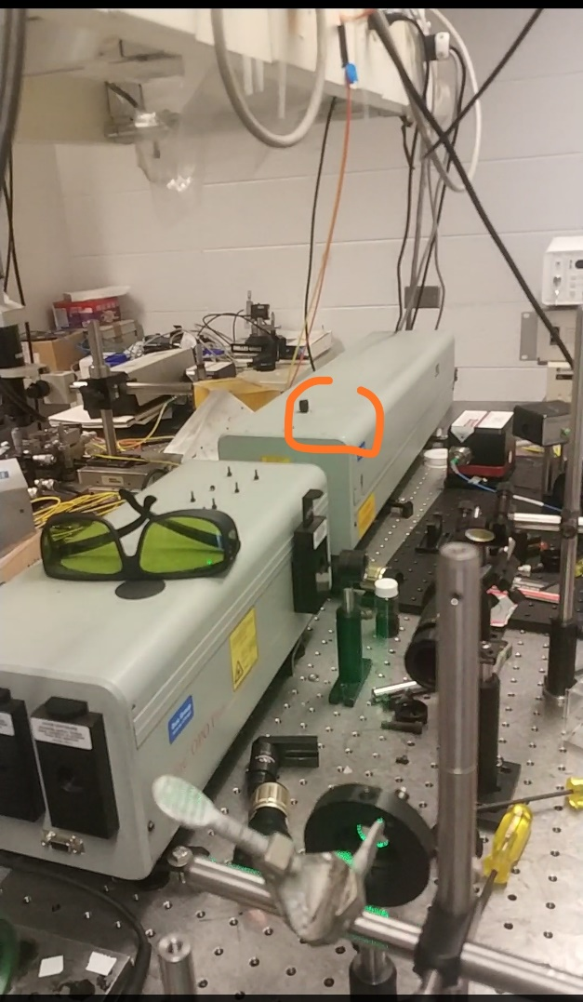

Be careful not to twist the knob on top of the cover!! That knob is designed to optimize the alignment of doubler inside the optical pathway. When changing the component inside, don’t touch that knob.

The DI water filter should be changed every three to six months (along with the distilled water). The flashlamp should be replace every twelve months.

There are nine programmed error messages. When they appear, they are accompanied by flashing and beeping. The definitions for the error messages are given below. Refer to Table 12 Electrical troubleshooting on page 71 in manual to resolve these problems.

E00 Normal return.

E01 Surelite not in serial mode. Serial port is turned off. To operate in serial mode, press SELECT then ARROW UP button.

E02 Coolant flow interrupted. Check water level and kinks in water lines.

E03 Coolant temperature over temp. Cooling water temperature is too high.

E04 (not used)

E05 Laser head problems.

E06 External interlock. External interlock has opened.

E07 End of charge not detected before lamp fire.

E08 Lamp simmer not detected.

E09 Flow switch stuck on.

CSE This is displayed if a “check sum error” occurs in the EEPROM. This display means that the EEPROM has lost its saved memory and has reverted to preset software limits. It will be necessary to toggle through the display menu and re-enter the QA values for frequency (Fxx), lamp pump voltage, Q switch delay and pulse division (P01). If display does not go away after recycling key switch, contact Continuum.

